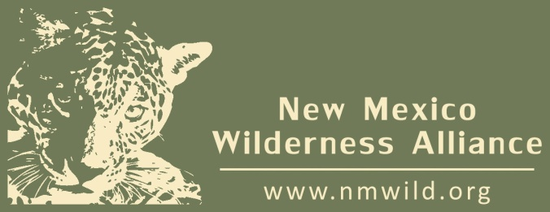

**New Mexico Wilderness Alliance**

142 Truman St. NE, Ste. B-1 • Albuquerque, NM 87108

[*www.nmwild.org*](http://www.nmwild.org) • 505-843-8696(o) • 505-843-8697(f)

#### 2013 ONLINE AUCTION PROCUREMENT FORM

###### March 2013 **•** *http://biddingforgood.com/nmwild*

Thank you for supporting wilderness protection in New Mexico. Help us protect the wild spaces that make the Land of Enchantment so enchanting.

|  |  |
| --- | --- |
| Donor or Company Name (as appears in the auction): Rio Grande Soaring Association  Please check here if you wish to remain anonymous | |
| Contact Person (if different from above): Had Robinson    Telephone Number: 915-726-2698 E-mail: had@RGSA.info | |
| Donor Address: 8105 Airport Rd. City: Santa Teresa, NM ZIP code: 88008 | |
| Signature of Donor (required): Date: Feb. 5, 2013 | |
| Please list names and phone numbers of additional possible donors: N/A | |
| Auction Item Name: Paraglider Tandem Flight | |
| Detailed Item/ Description for auction website: An FAA licensed pilot will give a tandem paraglider flight to the winning bidder. The flight location will be the Magdalena Rim launch near Magdalena Peak, Dona Ana County, NM. The flight will be scheduled at a time convenient for the passenger, weather conditions permitting. | *For Office Use Only*  Procurement # |
| Value (fair market value required): $275 | |
| Expiration Date and Restrictions/Limitations: Expiration 07/13. Passenger for flight must be in reasonably good physical condition, able to run a short distance, and accustomed to heights. The pilot in command will make the final decision regarding the passenger’s fitness to make the flight. | |

|  |  |  |  |
| --- | --- | --- | --- |
| Item (check all that apply): | Accompanies donor form  Will be delivered by donor | Not displayed at auction  Pick-up by auction rep. | Donor to provide certificate  Auction to make certificate |

**Please mail or deliver items to NM Wild by March 1, 2013.**

**NM Wild Auction Representative:**

**Please keep one copy of this form as your receipt and attach the other form to the item**. NM Wild is a 501 (c)(3) organization. Federal EIN #85-0457916. All donations are deductible to the extent allowed by law. If you have questions regarding your donation, please contact 505-843-8696 x 104.